Arduino Battery Tester Documentation

For more information, see Instructables page: <https://www.instructables.com/How-to-Display-and-Set-Numbers-With-7-Segment-Disp/>

The PCB files and circuit diagrams are at: <https://github.com/bz36912/PCB> under joystick_n_7seg_PCB folder and shared_Altium_resources folders.

# Pin allocations

|  |  |  |
| --- | --- | --- |
| **Pin name in Code** | **Arduino pin number** | **Description** |
| Display | | |
| PARALLEL_CLK | 8 | OUTPUT. Parallel clock. For the 8-bit shift register, the serial clock pulses 8 times for each time parallel clock pulses once |
| SERIAL_CLK | 7 | OUTPUT. Serial clock |
| SERIAL_IN | 6 | OUTPUT. Serial data |
| Joystick | | |
| X_VAL | A3 | INPUT. Measures the horizontal position |
| Y_VAL | A4 | INPUT. Measures the vertical position |
| BUTTON | A5 | INPUT. The push button (aka centre select) |
| Battery Tester / Voltmeter | | |
| BUZZER | 9 | OUTPUT (PWM). |
| VOLTAGE_PIN | A2 | INPUT. Measures the voltage with reference to GND. |

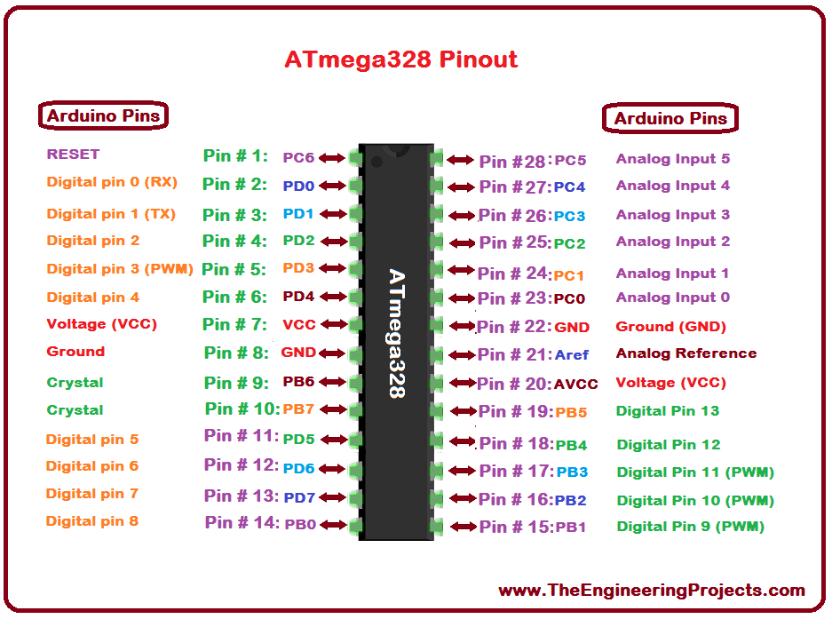

# Timer

|  |  |
| --- | --- |
| **Timer** | **Used by:** |
| 0 | Millis() and delay() |
| 1 (16-bit) | 7 segment display’s timer interrupt |
| 2 | Used by tone() function used for the buzzer. |



